**CS698 Lab 1**

1. Install UsingR and ISwR packages to your own directory
2. Using R for Introductory Statistics

Page 18: **1.1-1.12** (see below)

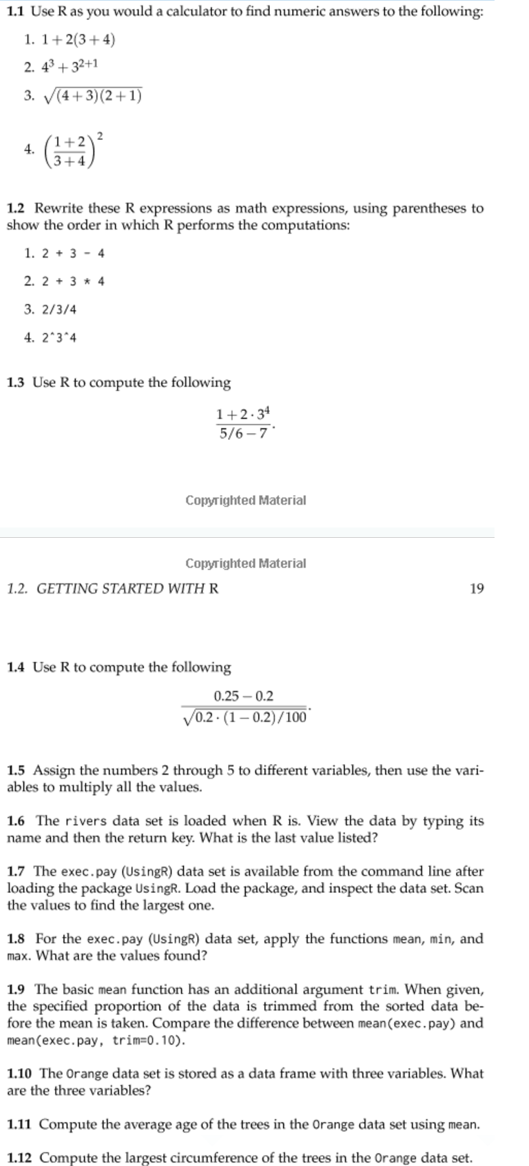

**1.18** Define x and y with

> x = c(1, 3, 5, 7, 9)

> y = c(2, 3, 5, 7, 11, 13)

Try to guess the results of these R commands:

1. x+1

2. y*2

3. length (x) and length (y)

4. x+y (recycling)

5. sum(x>5) and sum(x[x>5])

6. sum(x>5|x<3)

7. y[3]

8. y[−3]

9. y[x] (What is NA?)

10. y[y>=7]

Remember that you access entries in a vector with [].

1)

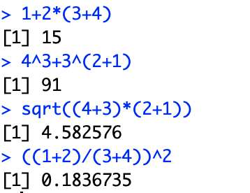

2)

((2+3)-4)

(2+(3*4))

((2/3)/4)

((2^3)^4)

3)

(1+2*3^4)(5/6-7)

4)

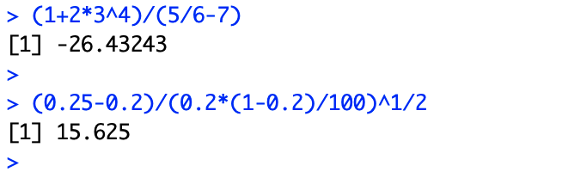

5)

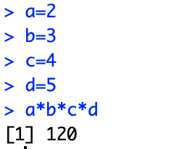

6)

7)

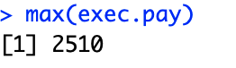

8)

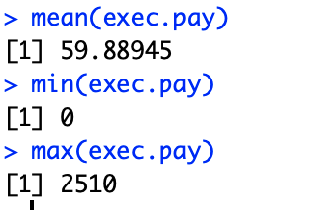

9)

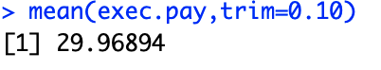

10)

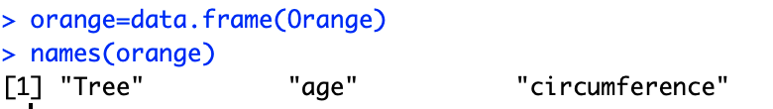

11)

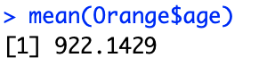

12)

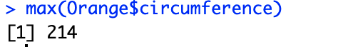

18)

